The rare example of stereoisomeric 2+2 metallacycles of porphyrins featuring chiral-at-metal octahedral ruthenium corners
Alessio Vidal,ª Federica Battistin,ª Gabriele Balducci,ª Nicola Demitri,^{b} Elisabetta Iengo,ª E. Alessioª*
ª Department of Chemical and Pharmaceutical Sciences, University of Trieste, Via L. Giorgieri 1, 34127 Trieste, Italy.
^{b} Elettra - Synchrotron Light Source, S.S. 14 Km 163.5, Area Science Park, 34149 Basovizza, Trieste, Italy.

Abstract
In this paper we describe three new stereoisomers of the already known 2+2 metallacycle of porphyrins [trans,cis,cis-RuCl₂(CO)₂(4′cisDPyP)]₂ (2, 4′cisDPyP = 5,10-bis(4′-pyridyl)-15,20-diphenylporphyrin), namely [{trans,cis,cis-RuCl₂(CO)₂}(4′cisDPyP)₂{cis,cis,cis-RuCl₂(CO)₂}] (14) and [cis,cis,cis-RuCl₂(CO)₂(4′cisDPyP)]₂ (15), in which the chiral {cis,cis,cis-RuCl₂(CO)₂} fragment has either a C or A handedness. The least abundant 15 exists as a mixture of two stereoisomers defined as alternate (15_{alt}, both porphyrins are trans to a Cl and a CO) and pairwise (15_{pw}, one porphyrin is trans to two chlorides and the other to two carbonyls), each one as a statistical mixture of meso (AC) and racemic (AA and CC) diastereomers. Remarkably, both 14 and 15 are – to the best of our knowledge – unprecedented examples of 2D metallacycles with octahedral chiral-at-metal connectors, and 14 is the first example of a 2+2 molecular square with stereoisomeric Ru(II) corners. Whereas 2 is selectively obtained by treatment of trans,cis,cis-RuCl₂(CO)₂(dmso-O)₂ (1) with 4′cisDPyP, 14 and 15 were obtained, together with 2 (major product), using stereoisomers of 1, either cis,cis,trans-RuCl₂(CO)₂(dmso-S)₂ (5) or cis,cis,cis-RuCl₂(CO)₂(dmso)₂ (6), as precursors.
From a general point of view, this work demonstrates that – even for the smallest 2+2 metallacycle and using a symmetric organic linker – several stereoisomers can be generated when using octahedral metal connectors of the type {MA₂B₂} that are not stereochemically rigid. As a proof-of-concept, it also opens the way to new – even though challenging – opportunities: unprecedented and yet unexplored chiral metallosupramolecular assemblies can be obtained and eventually exploited (e.g. for supramolecular catalysis) by using stereogenic octahedral metal connectors amenable to become chiral centers.
Introduction
Metal-mediated 2D and 3D discrete multi-porphyrin assemblies are investigated – besides for their structural beauty – for their chemical, electronic, photophysical and (photo)catalytic properties.¹⁻³ They feature a number of stable, rigid and flat tetrapyrrole rings in well-defined relative geometry. By virtue of their highly π-delocalized aromatic surface, the porphyrin units have intense electronic absorption bands in the visible region and a rather long fluorescence decay time, and the optical and redox properties can be further tuned with the insertion of inner metal ions. 3D structures, i.e. molecular cages that define a cavity, are also investigated as artificial molecular containers, sensors, and as (photo)reactors.²
The construction of such assemblies requires that porphyrins featuring peripheral binding sites are treated with appropriate metal precursors with two or more labile ligands. The large majority of examples concern homoleptic systems of the type M_{x}(porp)_{y}, i.e. composed by a single porphyrin (porp) and a single metal connector (M). Among the 2D structures, several examples of 2+2 and 4+4 metallacycles (i.e. molecular squares) have been reported, in which linear or 90°-angular porphyrins, very often featuring pyridyl moieties in meso positions, are connected by metal centers, typically either square-planar Pd(II) or Pt(II) fragments with cis or trans geometry, or octahedral cis-protected Ru(II), Re(I) or Rh(II)₂ moieties.¹ Conversely, two main types of homoleptic 3D porphyrin capsules have been reported: i) trigonal and hexagonal prisms obtained from the self-assembly of either 3′TPyP (5,10,15,20-tetra(3′-pyridyl)porphyrin) or 4′TPyP (5,10,15,20-tetra(4′-pyridyl)porphyrin), respectively, with cis-protected square planar Pd(II) or Pt(II) connectors;⁴⁻⁶ ii) tetrahedral M₄(porp)₆, cubic M₈(porp)₆, and cuboctahedral M₁₂(porp)₆ cages obtained by the self-assembly of porphyrins functionalized with two or four peripheral chelating units with naked octahedral metal ions (e.g. Fe(II), Co(II), Zn(II)).^{7,8}
In the past we have extensively exploited the Ru(II)-dmso carbonyl compound trans,cis,cis-RuCl₂(CO)₂(dmso-O)₂ (1, Scheme 1) as a well-behaved precursor for the preparation of porphyrin metallacycles.⁹ Compound 1 selectively replaces the two adjacent dmso-O ligands without geometrical changes, i.e. it is the precursor of a neutral cis-protected metal fragment.¹⁰⁻¹² When treated with a stoichiometric amount of 5,10-bis(4′-pyridyl)-15,20-diphenylporphyrin (4′cisDPyP) it affords in good yield the corresponding neutral 2+2 metallacycle (or molecular square) [t,c,c-RuCl₂(CO)₂(4′cisDPyP)]₂ (2), in which two adjacent porphyrins are connected through two octahedral {t,c,c-RuCl₂(CO)₂} fragments (Scheme 1).^{9,13,14} The zincated form of compound 2, [t,c,c-RuCl₂(CO)₂(Zn·4′cisDPyP)]₂ (2Zn), is perfectly flat in the solid state.¹⁵
Scheme 1. The preparation of the 2+2 porphyrin metallacycle [t,c,c-RuCl₂(CO)₂(4′cisDPyP)]₂ (2) from 1.

Treatment of the reactive “corner” compound t,c,c-RuCl₂(CO)₂(4′cisDPyP)₂ with the cis-protected Pd(dppp)(CF₃SO₃)₂ complex (dppp = diphenylphosphinopropane) allowed us to prepare [{t,c,c-RuCl₂(CO)₂}(4′cisDPyP)₂{Pd(dppp)}](CF₃SO₃)₂ (3, Figure 1), the first (and only) example of an heterobimetallic 2+2 metallacycle of porphyrins, featuring an octahedral Ru(II) and a square planar Pd(II) corner.¹⁶
When 5,10-bis(3′-pyridyl)-15,20-diphenylporphyrin (3′cisDPyP) was used, the corresponding 2+2 metallacycle [t,c,c-RuCl₂(CO)₂(3′cisDPyP)]₂ (4) was isolated and fully characterized. Contrary to 2, 4 has a staggered geometry with the two chromophores rigidly held in a slipped-cofacial arrangement (interplanar distance 4.18 Å) by the Ru(II) fragments (Figure 1).¹⁵ It is worth stressing that in the metallacycles 2-4 the connecting Ru(II) fragment, besides affording stable and inert bonds with all its ligands, is highly symmetric and thus generates no stereoisomers.
Figure 1. The porphyrin 2+2 metallacycles [{t,c,c-RuCl₂(CO)₂}(4′cisDPyP)₂{Pd(dppp)}](CF₃SO₃)₂ (3) and [t,c,c-RuCl₂(CO)₂(3′cisDPyP)]₂ (4).

Insertion of Zn(II) into the porphyrins transformed each molecular square into a panel with two embedded metal connectors, each one with an available axial binding site, that have been largely exploited by us for the modular construction of higher-order architectures, such as molecular sandwiches, boxes and prisms.^{1,13,17,18}
However, two other stereoisomers of 1 are known, namely c,c,t-RuCl₂(CO)₂(dmso-S)₂ (5) and c,c,c-RuCl₂(CO)₂(dmso)₂ (6) (Figure 2).^{10,19} To be noted that 5 and 6 are also linkage isomers, since in 6 the dmso trans to CO is bound through the oxygen atom (dmso-O).²⁰

Figure 2. The three stereoisomeric Ru(II) precursors used in this work: t,c,c-RuCl₂(CO)₂(dmso-O)₂ (1), c,c,t-RuCl₂(CO)₂(dmso-S)₂ (5), and c,c,c-RuCl₂(CO)₂(dmso)₂ (6).¹⁹

More than twenty years ago we reported that complex 5 reacts with pyridine (py) at room temperature in methanol or chloroform replacing one dmso-S and affording a mixture of two mono-substituted isomers: c,c,c-RuCl₂(CO)₂(dmso-S)(py) (7, minor) and c,c,t-RuCl₂(CO)₂(dmso-S)(py) (8, major). Conversely, when the reaction is performed in refluxing methanol both dmso ligands are replaced by pyridine affording t,c,c-RuCl₂(CO)₂(py)₂ (9), i.e. the same stereoisomer that is obtained from 1 at room temperature (Scheme 2). In other words, the substitution process is accompanied by isomerization.¹⁰
Scheme 2. The reactivity of the stereoisomers t,c,c-RuCl₂(CO)₂(dmso-O)₂ (1) and c,c,t-RuCl₂(CO)₂(dmso-S)₂ (5) towards pyridine (py).

We now reasoned that – if the reactivity with pyridine is extended to pyridylporphyrins – treatment of 5 with 4′cisDPyP is likely to produce also metallacycles of porphyrins, however with a different mechanism compared to 1, through a process that might involve the stereochemical rearrangement of the Ru fragment. Therefore, Ru connectors of different geometry might be trapped/obtained, such as {c,c,c-RuCl₂(CO)₂} and {c,c,t-RuCl₂(CO)₂}, leading to new 2+2 or 4+4 metallacycles. We also reasoned that the same considerations might apply to the all-cis isomer 6, whose reactivity towards the model ligand pyridine has not been explored yet.
Therefore, we performed a careful investigation of the reactivity of both isomers 5 and 6, first with the model ligand 5-(4′-pyridyl)-10,15,20-triphenylporphyrin (4′MPyP) and then with 4′cisDPyP. We describe here the isolation and characterization of two new 2+2 metallacycles of porphyrins that are stereoisomers of 2, namely [{t,c,c-RuCl₂(CO)₂}(4′cisDPyP)₂{c,c,c-RuCl₂(CO)₂}] (14) and [c,c,c-RuCl₂(CO)₂(4′cisDPyP)]₂ (15, that exists as a mixture of two stereoisomers defined as alternate and pairwise), in which the chiral {c,c,c-RuCl₂(CO)₂} fragment has either a C or A configuration (Chart 1).²¹

Chart 1. Example of how the chirality symbols C (clockwise) and A (anti-clockwise) are assigned to the enantiomers of the model complex c,c,c-RuCl₂(CO)₂(py)₂.²² The CIP priority number of each ligand is in italics.

In metallosupramolecular assemblies chirality can arise from the presence of a stable stereogenic element (either enantiopure or racemic) in the organic bridging ligand or in an auxiliary ligand attached to the metal center.²³ For example, Stang and co-workers described chiral 2+2 and 4+4 metallacycles of porphyrins in which 4′cisDPyP or 4′transDPyP units (4′transDPyP = 5,15-bis(4′-pyridyl)-10,20-diphenylporphyrin) are connected by Pd(II) corners bearing R(+)- or S(–)-BINAP as chiral ancillary ligand.²⁴ With a similar approach, Shinkai et al. described a chiral [Pd₄(porp)₂]⁸⁺ square prism in which two porphyrins bearing four pyridyl groups are connected by four cis-protected chiral {Pd[(R)-(+)-BINAP]}²⁺ fragments.²⁵

As an alternative, chirality of metallosupramolecular assemblies may derive from the presence of chiral metal connectors. There are many examples, some of which concerning also 3D multiporphyrin assemblies,^{6,7} in which chirality is generated by the spatial arrangements of achiral chelating ligands around the connecting octahedral metal centers (Λ or Δ handedness).^{26,27} Typically, in the solid state, all the chiral metal centers within each assembly adopt the same Λ or Δ configuration, in particular when the bridging ligands are rigid, since the chirality established at one metal vertex is transmitted to the other centers through strong mechanical coupling.²³ In some cases enantiopure Λ or Δ metallo-ligands were also prepared and then connected through achiral metal centers to afford enantiopure cages.²⁷ There are also a few examples of 2D or 3D assemblies (not concerning porphyrins) with tetrahedral half-sandwich chiral metal connectors with R or S configuration.²⁸⁻³⁰ Nevertheless, both 14 and 15 are – to the best of our knowledge – unprecedented examples of 2D metallosupramolecular assemblies with octahedral chiral-at-metal centers (with C or A handedness),²² and 14 is the first example of a 2+2 molecular square with stereoisomeric Ru(II) corners. Indeed, the stereogenic octahedral metal connectors with monodentate ligands, that may lead to this type of chirality in metallosupramolecular assemblies, are rare: Aside from the Ru(II) connectors described by us, the other most commonly used octahedral fragment is the achiral {fac-Re(CO)₃X} (X = Cl, Br).^{1,2}

Experimental section
Materials
All chemicals, including TLC silica gel plates, were purchased from Sigma-Aldrich and used as received. Solvents were of reagent grade. The ruthenium precursors t,c,c-RuCl₂(CO)₂(dmso-O)₂ (1), c,c,t-RuCl₂(CO)₂(dmso-S)₂ (5) and c,c,c-RuCl₂(CO)₂(dmso)₂ (6), the meso-pyridylporphyrins 4′MPyP and 4′cisDPyP, and pure samples of t,c,c-RuCl₂(CO)₂(4′MPyP)₂ (10) and of the metallacycle [t,c,c-RuCl₂(CO)₂(4′cisDPyP)]₂ (2) (obtained from 1) were synthesized and purified as previously reported by us.^{10,13,31}
Instrumental methods
Mono- and bi-dimensional (¹H-¹H COSY, ¹H-¹³C HSQC) NMR spectra were recorded at room temperature – unless stated otherwise – on a Varian 400 or 500 spectrometer (¹H: 400 or 500 MHz, ¹³C{¹H}: 100.5 or 125.7 MHz). ¹H DOSY experiments were recorded on the Varian 500 spectrometer at –5°C (CDCl₃), using the Bipolar Pulse Pair Stimulated Echo with Convection Compensation Sequence implemented into the VnmrJ software. ¹H and ¹³C{¹H} chemical shifts were referenced to the peak of residual non-deuterated solvent (δ = 7.26 and 77.16 for CDCl₃, 5.32 and 54.00 for CD₂Cl₂). Selected carbon resonances, except for carbonyls, were assigned through the HSQC spectra. ESI mass spectra were collected in the positive mode on a Perkin-Elmer APII spectrometer at 5600 eV. However, as typical for such neutral systems,¹ the ESI-MS spectra of the model complexes and metallacycles of porphyrins only showed peaks deriving from the fragmentation. The UV-vis spectra were obtained on an Agilent Cary 60 spectrophotometer, using 1.0 cm path-length quartz cuvettes (3.0 mL). Infrared spectra of chloroform solutions in the CO stretching region were recorded between CaF₂ windows (0.5 mm spacer) on a Perkin-Elmer Fourier-transform IR/Raman 2000 instrument in the transmission mode. A CEM Discover microwave reactor was used for the microwave-assisted reactions performed in 10 mL vessels. Elemental analyses were performed on a Thermo Flash 2000 CHNS/O analyzer in the Department of Chemistry of the University of Bologna (Italy). Analysis was not performed on the metallacycles obtained by preparative TLC because of the low amounts. In addition, elemental analysis – unless is performed on the crystal samples (such as those used for X-ray determinations) – is poorly significant for these systems due to the typical presence of crystallization molecules whose nature and number vary from batch to batch.
X-ray diffraction
Data collections were performed at the X-ray diffraction beamline (XRD1) of the Elettra Synchrotron of Trieste (Italy) equipped with a Pilatus 2M image plate detector.
Collection temperature was 100K (nitrogen stream supplied through an Oxford Cryostream 700); the wavelength of the monochromatic X-ray beam was 0.700 Å and the diffractograms were obtained with the rotating crystal method. The crystals were dipped in N-paratone and mounted on the goniometer head with a nylon loop. The diffraction data were indexed, integrated and scaled using the XDS code.³² The structures were solved by the dual space algorithm implemented in the SHELXT code.³³ Fourier analysis and refinement were performed by the full-matrix least-squares methods based on F² implemented in SHELXL.³⁴ The Coot program was used for modeling.³⁵ Anisotropic thermal motion was allowed for all non-hydrogen atoms. Hydrogen atoms were placed at calculated positions with isotropic factors U = 1.2×U_{eq}, U_{eq} being the equivalent isotropic thermal factor of the bonded non hydrogen atom. Crystal data and details of refinements are in the ESI.
Synthesis of the complexes
As written in the Result and Discussion, very similar results were obtained by treatment of either 5 or 6 with the pyridylporphyrins under the same reaction conditions. Thus, only one procedure is reported in each case.
c,c,t-RuCl₂(CO)₂(dmso-S)(4′MPyP) (11). A 10.9 mg amount (0.028 mmol) of colorless c,c,t-RuCl₂(CO)₂(dmso-S)₂ (5) was dissolved in 7 mL of chloroform. After addition of 25.8 mg of 4′MPyP (0.042 mmol, 1:1.5 ratio) the purple solution was heated in a microwave reactor at 70°C for 2 h. The solvent was then removed by rotary evaporation and the violet powder was partially dissolved in 5 mL of acetone, where the unreacted porphyrin is insoluble. The undissolved 4′MPyP was removed by filtration, the solution was rotary evaporated to dryness and the solid (pure 11, according to the ¹H NMR spectrum) was dried in vacuo. (Yield 19.3 mg, 75%). Elemental analysis calcd for [C₄₇H₃₅Cl₂N₅O₃SRu] (M_{w}: 921.1): C 61.24; H 3.83; N 7.60. Found: C 61.33; H 3.94; N 7.68. ¹H NMR (CDCl₃), δ (ppm): 9.30 (d, 2H: H2,6), 8.87 (m, 8H: Hβ), 8.35 (d, 2H: H3,5), 8.22 (d, 6H: o-H), 7.78 (m, 9H: m+p-H), 3.65 (s, 6H: dmso-S), –2.79 (s, 2H: NH). ¹³C NMR (CDCl₃), δ (ppm): 188.68 (CO), 153.11 (C2,6), 141.76 (Cβ), 134.54 (o-C), 131.42 (C3,5), 126.76 (m+p-C), 46.96 (dmso-S). Selected IR absorption (chloroform solution, cm⁻¹): 2068 (ν_{CO}), 1980 (ν_{CO}). UV-vis (CHCl₃) λ_{max}, nm (relative intensity, %): 420 (100), 519 (8.7), 554 (4.4), 591 (3.16), 646 (2.32).
t,c,c-RuCl₂(CO)₂(4′MPyP)₂ (10), c,c,t-RuCl₂(CO)₂(4′MPyP)₂ (12), and c,c,c-RuCl₂(CO)₂(4′MPyP)₂ (13).
A 15.0 mg amount (0.039 mmol) of c,c,t-RuCl₂(CO)₂(dmso-S)₂ (5) was dissolved in 7 mL of a 4:5 CHCl₃:MeOH mixture. After addition of 52.9 mg of 4′MPyP (0.086 mmol, 4′MPyP/Ru = 2.2) the purple solution was heated in a microwave reactor at 100°C for 4 h. The solvent was removed under vacuum and the mixture was subjected to column chromatography on silica gel eluted with CHCl₃ for the first two fractions, that contained t,c,c-RuCl₂(CO)₂(4′MPyP)₂ (10) and c,c,t-RuCl₂(CO)₂(4′MPyP)₂ (12), respectively, and then with CHCl₃/EtOH 98/2 v/v for the third fraction that contained c,c,c-RuCl₂(CO)₂(4′MPyP)₂ (13). Each product was then obtained as a purple solid by rotary evaporation of the eluent. Yields and R_{f}’s (TLC on silica plates using chloroform as eluent): 10 12%, 0.88; 12 7%, 0.24; 13 3%, 0.18. X-ray quality crystals of 10 and 12 were obtained by slow diffusion of n-hexane (10) or diethyl ether (12) into a chloroform solution of each complex.
t,c,c-RuCl₂(CO)₂(4′MPyP)₂ (10). Elemental analysis calcd for [C₈₈H₅₈Cl₂N₁₀O₂Ru]·0.5(C₆H₁₄) (M_{w}: 1502.4): C 72.69; H 4.42; N 9.32. Found: C 72.78; H 4.49; N 9.41. ¹H MR (CDCl₃), δ (ppm): 9.59 (d, 4H, H2,6), 8.86 (m, 16H, Hβ), 8.45 (d, 4H, H3,5), 8.20 (d, 4H, o-H phenyl ring in position 10), 8.15 (d, 8H, o-H phenyl rings in positions 5 and 15), 7.77 (m, 6H, m+pH phenyl ring in position 10), 7.69 (m, 12H, m+pH phenyl rings in positions 5 and 15), –2.80 (s, 4H, NH). Selected ¹³C NMR signals (from the HSQC spectrum) in CDCl₃, δ (ppm): 154.8 (C2,6), 134.3 (o-C), 131.2 (C3,5), 127.8 (m+p-C). Selected IR absorption (chloroform solution, cm^{–1}): 2073 (ν_{CO}), 2015 (ν_{CO}). UV-vis (CHCl₃) λ_{max}, nm (relative intensity, %): 420 (100), 517 (4.8), 552 (2.5), 591 (2.2), 644 (0.6).
c,c,t-RuCl₂(CO)₂(4′MPyP)₂ (12). Elemental analysis calcd for [C₈₈H₅₈Cl₂N₁₀O₂Ru]·1.3 CHCl₃·C₄H₁₀O (M_{w}: 1688.3): C 66.36; H 4.14; N 8.29. Found: C 66.48; H 4.20; N 8.35. ¹H NMR (CDCl₃), δ (ppm): 9.58 (d, 4H, H2,6), 8.98 (d, 4H, Hβ), 8.93 (d, 4H, Hβ), 8.88 (s, 8H, Hβ), 8.34 (d, 4H, H3,5), 8.23 (m, 12H, o-H), 7.81 (m, 18H, m+pH), –2.77 (s, 4H, NH). Selected ¹³C NMR signals (from the HSQC spectrum) in CDCl₃, δ (ppm): 154.4 (C2,6), 134.5 (o-C), 131.1 (C3,5), 127.4 (m+p-C). Selected IR absorption (chloroform solution, cm^{–1}): 2063 (ν_{CO}), 1995 (ν_{CO}). UV-vis (CHCl₃) λ_{max}, nm (relative intensity, %): 423 (100), 452 (9.2), 517 (6.0), 550 (3.4), 588 (2.6), 648 (0.9).
c,c,c-RuCl₂(CO)₂(4′MPyP)₂ (13). Elemental analysis calcd for [C₈₈H₅₈Cl₂N₁₀O₂Ru]·CHCl₃ (M_{w}: 1578.8): C 67.71; H 3.77; N 8.87. Found: C 67.63; H 3.72; N 8.78. ¹H NMR (CDCl₃), δ (ppm): 9.54 (d, 2H, H2,6), 9.33 (d, 2H, H2,6), 8.86 (m, 16H, Hβ), 8.49 (d, 2H, H3,5), 8.38 (d, 2H, H3,5), 8.21 (m, 4H, o-H phenyl ring in position 10), 8.17 (m, 8H, o-H phenyl rings in positions 5 and 15), 7.78 (m, 6H, m + p H phenyl ring in position 10), 7.71 (m, 12H, m +p H phenyl rings in positions 5 and 15), –2.79 (s, 4H, NH). Selected ¹³C NMR signals (from the HSQC spectrum) in CDCl₃, δ (ppm): 154.5 (C2,6), 134.6 (o-C), 131.1 (C3,5), 127.0 (m+p-C). Selected IR absorption (chloroform solution, cm^{–1}): 2072 (ν_{CO}), 2001 (ν_{CO}). UV-vis (CHCl₃) λ_{max}, nm (relative intensity, %): 422 (100), 452 (30), 517 (5.1), 555 (3.0), 592 (2.3), 650 (3.8).
[t,c,c-RuCl₂(CO)₂(4′cisDPyP)]₂ (2),[{t,c,c-RuCl₂(CO)₂}(4′cisDPyP)₂{c,c,c-RuCl₂(CO)₂}] (14), [c,c,c-RuCl₂(CO)₂(4′cisDPyP)]₂ (15).
A 20.0 mg amount of 4′-cisDPyP (0.032 mmol), was dissolved in a methanol:chloroform 5:4 mixture (2.6 mL of CHCl₃ and 3.2 mL of MeOH). After addition of 11.2 mg of 5 (0.029 mmol, 4′cisDPyP/Ru = 1.1) the purple solution was heated in a microwave reactor at 100°C for 2 h.
The purple precipitate that formed was filtered, washed with methanol and subjected to preparative TLC on silica plates using chloroform as eluent. Three main products were separated, in the order: [t,c,c-RuCl₂(CO)₂(4′cisDPyP)]₂ (2), [{t,c,c-RuCl₂(CO)₂}(4′cisDPyP)₂{c,c,c-RuCl₂(CO)₂}] (14), and [c,c,c-RuCl₂(CO)₂}(4′cisDPyP)]₂ (15). According to TLC analysis, the mother liquor from the MW reaction contained smaller amounts of the three metallacycles plus unreacted 4′cisDPyP and other unidentified minor species with R_{f} values < 0.2, i.e. most likely intermediates in the formation of the 2+2 molecular squares.
Yields and R_{f}’s on TLC silica plates eluted with CHCl₃:EtOH 99.5:0.5: [t,c,c-RuCl₂(CO)₂(4′cisDPyP)]₂ (2) 24%, 0.95; [{t,c,c-RuCl₂(CO)₂}(4′cisDPyP)₂{c,c,c-RuCl₂(CO)₂}] (14) 14%, 0.38; [c,c,c-RuCl₂(CO)₂(4′cisDPyP)]₂ (15) 0.7%, 0.21.
¹H DOSY diffusion coefficients (cm² s^{–1} ×10⁶) (CDCl₃, –5°C): 2.96 (2), 2.86 (14), 3.10 (15).
[{t,c,c-RuCl₂(CO)₂}(4′cisDPyP)₂{c,c,c-RuCl₂(CO)₂}] (14). ¹H NMR (CDCl_{3,} –5 °C), δ (ppm) 9.92 (d, 1H, H2,6), 9.85 (d, 1H, H2,6), 9.81 (d, 1H, H2,6), 9.75(m, 3H, H2,6), 9.43 (d, 1H, H2,6), 9.18 (d, 1H, H2,6), ), 9.07 (m, 12H, Hβ), 8.91 (m, 4H, Hβ), 8.71 (dd, 1H, H3,5), 8.61 (m, 6H, H3,5), 8.50 (dd, 1H, H3,5), 8.27 (m, 8H, o-H phenyl rings), 7.86 (m, 12H, m+p-H phenyl rings), –2.72 (s, 4H, NH). Selected ¹³C NMR signals (from the HSQC spectrum) in CDCl₃, δ (ppm): 154.1, 154.0, 152.1, 151.4, 150.8, and 150.7 (C2,6); 132.9, 132.6, 132.5, 132.1, and 131.8 (C3,5); 134.5 (oC-phenyl rings); 128.3 and 127,0. (m+pC-phenyl rings). Selected IR absorption (chloroform solution, cm^{–1}): 2075 (ν_{CO}), 2015 (ν_{CO}), 2002(ν_{CO}). UV-vis (CHCl₃) λ_{max}, nm (relative intensity, %): 429.5 (100), 521.0 (7.7), 557 (4.4), 594 (3.3),650 (2.3).
[c,c,c-RuCl₂(CO)₂(4′cisDPyP)]₂ (15). Selected IR absorption (chloroform solution, cm^{–1}): 2074 and 2001 cm⁻¹. UV-vis (CHCl₃) λ_{max}, nm (relative intensity, %): 430.0 (100), 522.0 (6.9), 559 (4.3), 595 (3.4), 651 (3.0).

Results and Discussion
Reactions with 4′MPyP
First, we investigated the reactivity of the two RuCl₂(CO)₂(dmso)₂ isomers – 5 and 6 – towards 4′MPyP. The reactions were monitored through TLC analysis and proton NMR spectroscopy. Coordination of 4′MPyP to the Ru(II) fragment induces typical downfield shifts for the resonances of the pyridyl ring protons (H2,6 and H3,5), whereas the other porphyrin resonances are scarcely affected. As a reference we had a sample of pure t,c,c-RuCl₂(CO)₂(4′MPyP)₂ (10), previously prepared by us from 1.³¹
Both isomers 5 and 6, when treated with one equiv of 4′MPyP in CDCl₃ at room temperature, slowly replace one dmso yielding a largely prevailing compound that, according to its ¹H NMR spectrum, was identified as c,c,t-RuCl₂(CO)₂(dmso-S)(4′MPyP) (11) (Scheme 3), i.e. the analog of the pyridine product 8. When the reaction between 6 and 4′MPyP, performed in CDCl₃, was monitored by NMR spectroscopy we noticed that the formation of 11 – which implies a geometrical rearrangement – is accompanied by a progressive isomerization of the remaining complex into its stereoisomer 5 that was complete after ca. 24h. Thus it is possible that formation of 11 from 6 is subsequent to its isomerization to 5.
Scheme 3. The reactivity of c,c,t-RuCl₂(CO)₂(dmso-S)₂ (5) and c,c,c-RuCl₂(CO)₂(dmso)₂ (6) towards 4′MPyP in chloroform at room temperature.

Compound 11 was also the main product when either 5 or 6 were treated with a slight excess of 4′MPyP in chloroform at higher temperature (either at reflux for 15h or for 3h at 70°C under MW-assisted conditions). The compound could be obtained in almost pure form and its spectroscopic features are fully consistent with the proposed geometry: two CO stretching bands at 2068 and 1980 cm^{–1} – but a single resonance at 188.68 ppm in the ¹³C{¹H} NMR spectrum – for the adjacent and equivalent carbonyls, a singlet at 3.65 ppm for the equivalent methyl groups of the dmso-S in the ¹H NMR spectrum (ESI).
Substitution of the second dmso ligand from 5 and 6 required, besides higher temperatures and prolonged reaction times, the presence of methanol in the reaction mixture. When different CHCl₃:MeOH mixtures were tested, we found that the TLC spots attributable to disubstituted products – that typically have greater TLC mobility compared to 4′MPyP and 11 – increased upon increasing the relative amount of methanol and the temperature. All the reactions described below were eventually performed in a 4:5 CHCl₃:MeOH mixture (i.e. the highest content of methanol in which both 4′MPyP and 4′cisDPyP are still fully soluble) in a microwave reactor.
When the MW-assisted reaction between either 5 or 6 and 4′MPyP (2 equiv) was performed at 100°C, the main product was the already known trans,cis,cis-RuCl₂(CO)₂(4′MPyP)₂ (10),³¹ suggesting that it is the thermodynamically favored species. Crystals of 10 suitable for X-ray analysis were obtained by slow diffusion of diethyl ether into a CHCl₃ solution. The solid state molecular structure (Figure 3) fully confirms the nature of 10 as already established spectroscopically in solution.³¹

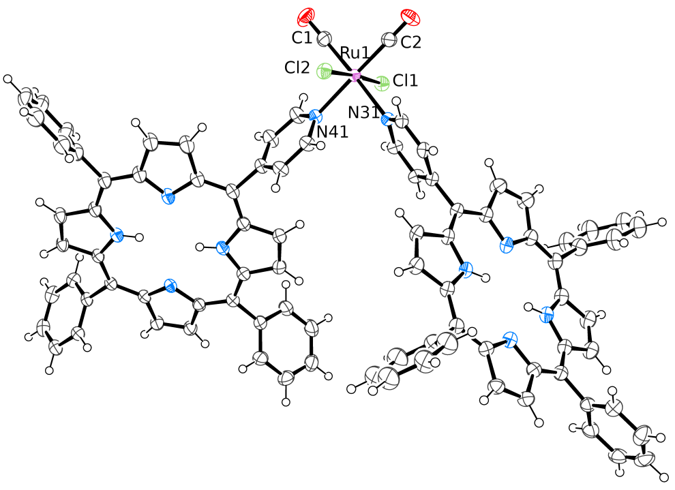

Figure 3. ORTEP representation (50% probability ellipsoids) of the solid state molecular structure of trans,cis,cis-RuCl₂(CO)₂(4′MPyP)₂·0.5C₆H₁₄ (10·0.5C₆H₁₄). For clarity, an hexane crystallization molecule has been omitted; for the same reason, only major populations (0.88, 0.85) of two disordered phenyl groups of the N31 porphyrin ligand have been included.

More importantly, besides a minor amount of residual 11, the spots of two new products with R_{f} = 0.24 and 0.18, respectively, were observed in the TLC analysis (CHCl₃; under these conditions the R_{f} of 10 is 0.88). Column chromatography performed on the raw mixture afforded three main bands. The first band contained pure 10. The spectral features of the product in the second band, i.e. a single set of resonances for coordinated 4′MPyP and no resonance for dmso in the ¹H NMR spectrum (ESI), and two CO stretching bands in the IR spectrum at 2063 and 1995 cm⁻¹, were consistent with the stereoisomer c,c,t-RuCl₂(CO)₂(4′MPyP)₂ (12). We notice that both carbonyl stretching bands in 12 fall at lower frequencies compared to those in 10 (2073 and 2015 cm⁻¹), as expected for CO being trans to the good π-donor Cl rather than to a pyridyl ring.³⁶ The geometry of 12 was confirmed by single crystal X-ray analysis (Figure 4). The pyridyl ring of each 4′MPyP in both 10 and 12 is – as expected – almost orthogonal to the coordination plane and to the porphyrin ring (dihedral angles in the range 56.6 – 79.9°). As a consequence, in the solid state the two porphyrin macrocycles form a dihedral angle of ca. 78° in 10 and ca. 12° in 12.

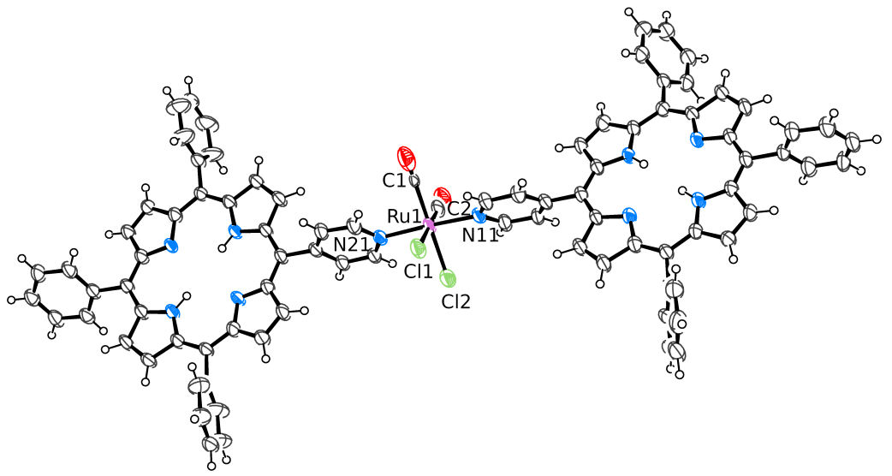

Figure 4. ORTEP representation (50% probability ellipsoids) of the solid state molecular structure of c,c,t-RuCl₂(CO)₂(4′MPyP)₂·1.3CHCl₃·C₄H₁₀O (12·1.3CHCl₃·C₄H₁₀O). For clarity, the chloroform and hexane crystallization molecules have been omitted.

The third band, whose mobility on silica gel is very close to that of unreacted 4′MPyP (R_{f} = 0.15), contained a product whose spectral features are fully consistent with the c,c,c-RuCl₂(CO)₂(4′MPyP)₂ (13) stereoisomer. In fact, the ¹H NMR spectrum (Figure 5) shows two equally intense and well resolved sets of resonances for the H2,6 and H3,5 protons, pairwise connected in the H-H COSY spectrum, for the two inequivalent 4′MPyP ligands, whose other resonances are partially or completely overlapping, including the singlets of the internal NH protons. By comparison with the spectra of 2 and 10 (all pyridyl rings trans to CO), we tentatively assign the most upfield pair of H2,6 and H3,5 resonances (red dots in Figure 5) to the pyridyl ring trans to Cl. To be noted that the phenyl resonances are split into two sets in 2:1 intensity ratio. This feature, that is observed also in the spectrum of 10 (but is absent in that of 12), is typical for two adjacent pyridylporphyrins in free rotation about the Ru–N_{pyridyl} bond.^{16,31} The IR spectrum shows two CO stretching bands for the adjacent carbonyls at 2072 and 2001 cm^{–1}. No attempts were made to separate the racemic mixture of the C and A enantiomers.
Figure 5. ¹H NMR spectrum of c,c,c-RuCl₂(CO)₂(4′MPyP)₂ (13) in CDCl₃. Dots of the same color indicate protons belonging to the same pyridyl ring.

In summary, the main results obtained with the model mono-pyridylporphyrin showed that: i) the two stereoisomers 5 and 6 react with 4′MPyP affording the same products, ii) in chloroform/methanol mixtures the disubstituted compound 10 – that was selectively obtained from 1 – is the thermodynamically preferred product, followed by lower amounts of its stereoisomers 12 and 13.³⁷ In principle, in analogy to 10, the geometry of the Ru fragment in 13, with two adjacent porphyrins, is suitable for the formation of 2+2 metallacycles when using 4′cisDPyP. Thus, both 10 and 13 are model corner compounds. Conversely, the geometry of the metal fragment in 12, with two opposite porphyrins, might lead to the formation of a statistically less favorable 4+4 metallacycle [c,c,t-RuCl₂(CO)₂(4′cisDPyP)]₄, in which the porphyrins occupy the corners of the square and the Ru fragments define the sides.¹ It is worth noting that the orientation of the two porphyrins in 12 is very close to that expected to be found in such hypothetical 4+4 metallacycle, making it a realistic model.

Reactions of 5 and 6 with 4′cisDPyP
Reactions between either 5 or 6 and an equivalent amount of 4′cisDPyP were best performed in a microwave reactor at 100°C in 4:5 CHCl₃: MeOH solution, affording a purple precipitate. A preliminary screening showed that the highest conversion was obtained after 2h.
Careful TLC analysis of the precipitate dissolved in chloroform showed that the raw product contained mainly 2 (R_{f} = 0.95). However, the spots of two other compounds of lower intensity (14 and 15, respectively) were clearly identified.³⁸ According to their mobility on silica gel (R_{f} = 0.38 for 14, and R_{f} = 0.21 for 15) both compounds were identified as metallacycles (typically, open oligomeric species are not eluted, and the R_{f} of the free 4′cisDPyP is < 0.1 under these conditions).
Pure samples of 14 and 15 (this latter in a very small amount) were best obtained by preparative TLC. Both species are well soluble in chloroform, again in agreement with being discrete – rather than oligomeric – species. Compound 14 was fully characterized by IR, 1D and 2D NMR and UV-vis spectroscopy. Taken together, the spectroscopic features are fully consistent with the hypothesis that 14 is a stereoisomer of 10, i.e. the 2+2 metallacycle [{t,c,c-RuCl₂(CO)₂}(4′cisDPyP)₂{c,c,c-RuCl₂(CO)₂}] featuring two stereoisomeric Ru(II) corners, one of which is a chiral center with C or A configuration (and therefore is a racemic mixture). Consistent with a metallacyclic (closed) structure, the NMR resonances of the pyridyl protons of 14 occur at higher frequency than in the free 4′cisDPyP. In the CDCl₃ spectrum at room temperature such resonances are rather broad. Upon lowering the temperature to ca. –5°C, they become increasingly sharper, whereas those of other protons start to broaden (ESI). For lower temperatures (between –5 and –25°C) all resonances become increasingly broader. This behavior suggests that the rotation about the C_{meso}–C_{ring} for the pyridyl rings (that are also bound to Ru) is already slow on the NMR time scale at ca. 0°C, whereas other motions – most likely the rotation of the phenyl rings – are relatively fast at 25°C and start to slow down at lower temperatures. Even at temperatures as low as –80°C, obtained in CD₂Cl₂ (ESI), the resonances are still broad. Figure 6 shows the spectrum at –5°C in CDCl₃, where eight doublets (1H each) are observed both for the H2,6 protons between 9.92 and 9.18 ppm (three partially overlapping at ca. 9.75 ppm) and for the H3,5 protons between 8.75 and 8.48 ppm (two overlapping at 8.63 ppm and four at 8.60 ppm). The assignment was confirmed by the HMQC spectrum (ESI). The number of pyridyl proton resonances and their spread is consistent with the fact that 14, in which one of the Ru corners is chiral, has no symmetry elements. As a consequence, each pyridyl proton resonates at a different frequency (with some accidental overlapping). The low-T ROESY spectrum (ESI) clearly shows that the two H2,6 resonances that fall at lowest frequencies are pairwise connected with the two at highest frequencies by exchange cross peaks, qualifying them as belonging to two distinct pyridyl rings. Similar cross peaks are found for the H3,5 resonances, even though their spread is smaller. These findings, together with the COSY connectivity, allowed us to define unambiguously two sets of four resonances (colored dots in Figure 6). We tentatively assign them to the two pyridyl rings bound to the asymmetric Ru fragment, since these protons are expected to experience chemical and magnetic environments much more diverse above and below the macrocycle plane (either a Cl or a CO) compared to those on the pyridyl rings bound to the symmetric {t,c,c-RuCl₂(CO)₂} corner. The resonances of the other types of protons are not resolved. For example, the four NH protons resonate as a relatively broad singlet at –2.8 ppm.

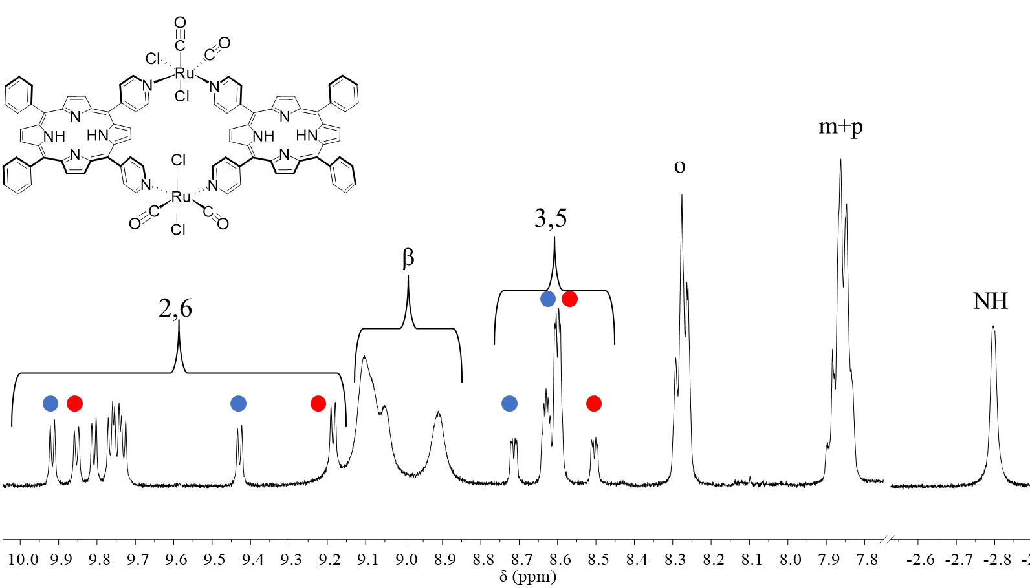
Figure 6. ¹H NMR spectrum of [{t,c,c-RuCl₂(CO)₂}(4′cisDPyP)₂{c,c,c-RuCl₂(CO)₂}] (14) in CDCl₃ at –5°C. Dots of the same color indicate protons belonging to the same pyridine ring.

In further agreement with our hypothesis, ¹H DOSY spectra of compounds 2 and 14 – performed under the same conditions (CDCl₃, –5°C) – afforded almost identical diffusion coefficients (ESI)
The IR spectrum of 14 in chloroform solution shows three bands in ca. 2:1:1 intensity ratio in the CO stretching region (Figure 7). The one at highest frequency is almost coincident with the average high-frequency band in the spectra of the model 4′MPyP compounds 10 and 13 (that differ only by ca. 10 cm^{–1}). Similarly, each one the two partially resolved bands in the lower frequency region is almost coincident with the low frequency band of 10 and 13, respectively (that differ by ca. 20 cm^{–1}). This finding is thus consistent with the presence in 14 of one {t,c,c-RuCl₂(CO)₂(4′cisDPyP)₂} corner similar to 10, and of one {c,c,c-RuCl₂(CO)₂(4′cisDPyP)₂} corner similar to 13. By comparison, the IR spectrum of 2 shows only two CO stretching bands at 2075 and 2015 cm^{–1}, i.e. very similar to those of the corresponding model complex 10.
Regretfully, repeated attempts to grow single crystals of 14 suitable for X-ray analysis were unsuccessful.
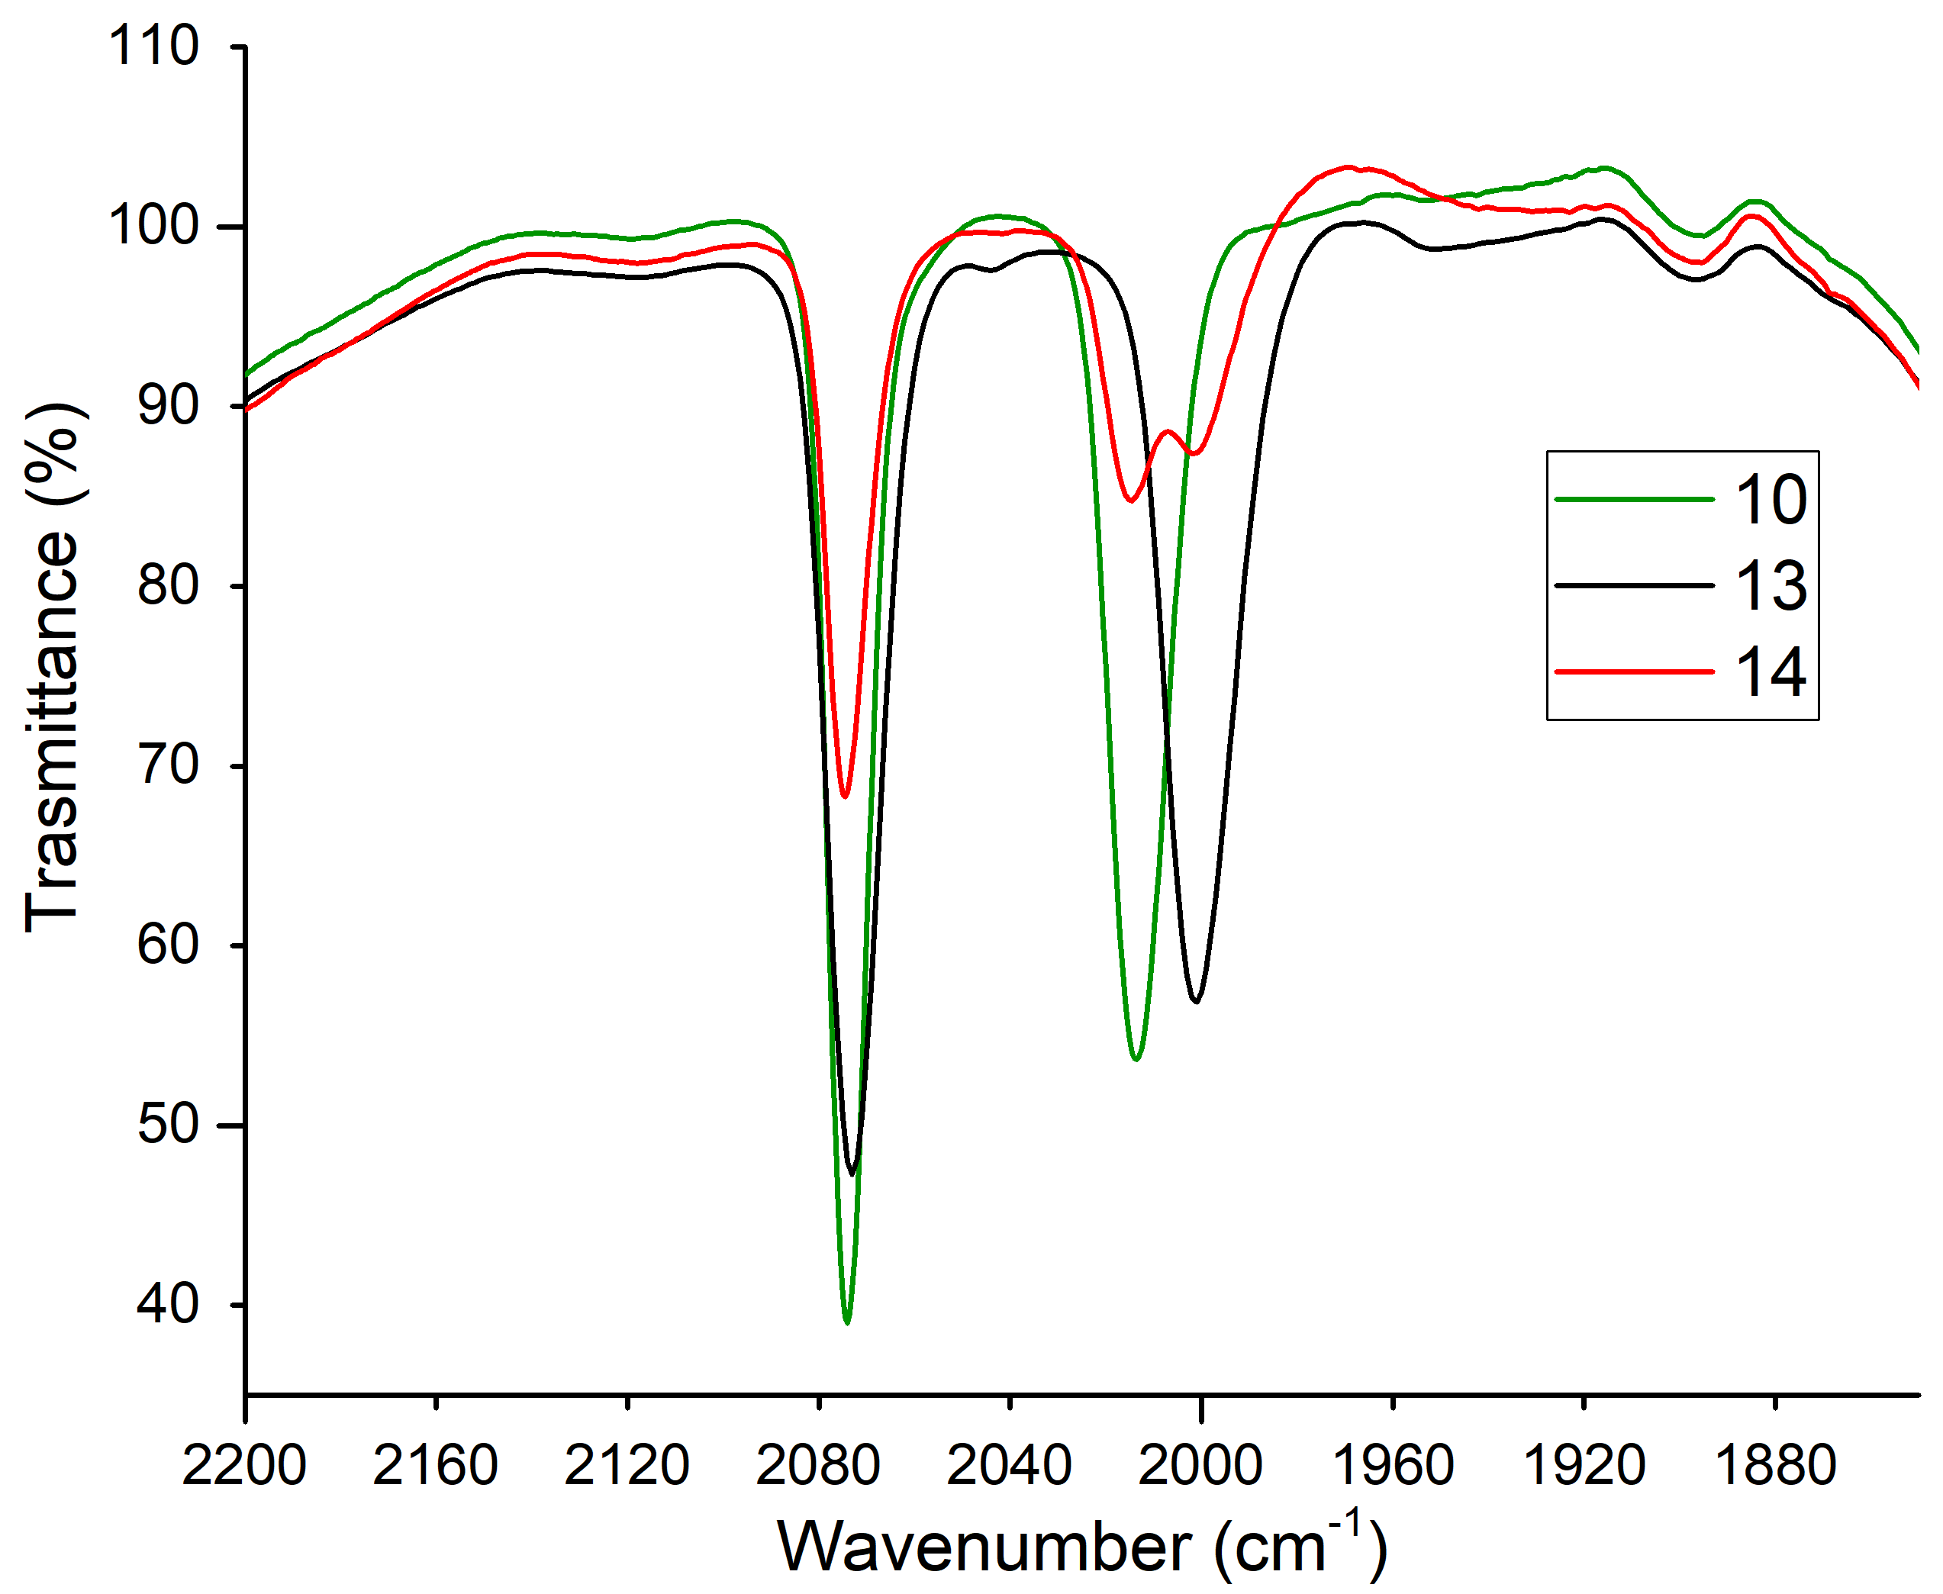
Figure 7. CO stretching region in the IR spectra of t,c,c-RuCl₂(CO)₂(4′MPyP)₂ (10), c,c,c-RuCl₂(CO)₂(4′MPyP)₂ (13) and [{t,c,c-RuCl₂(CO)₂}(4′cisDPyP)₂{c,c,c-RuCl₂(CO)₂}] (14) in CHCl₃ solution.

The spectral features of the least abundant compound 15, obtained in very small amount from the third band of the preparative TLC, strongly suggest that it is the third stereoisomeric metallacycle [c,c,c-RuCl₂(CO)₂(4′cisDPyP)]₂ (15). Consistent with this hypothesis: i) the ¹H DOSY diffusion coefficient of 15 is almost identical to those of 2 and 14 (ESI); ii) the IR spectrum in chloroform (Figure 8) shows only two CO stretching bands at 2074 and 2001cm⁻¹ , i.e. very similar to those found in the model corner compound 13 (2072 and 2001 cm⁻¹).

Figure 8. CO stretching region in the IR spectra of c,c,c-RuCl₂(CO)₂(4′MPyP)₂ (13) and [c,c,c-RuCl₂(CO)₂(4′cisDPyP)]₂ (15) in CHCl₃ solution.

The ¹H NMR spectrum of 15 at –5°C (Figure 9) is similar to that of 14, except for the larger number of partially resolved H2,6 resonances in the same spectral region. They are coupled to the less spread out and more overlapped H3,5 resonances in the H-H COSY spectrum (ESI). This feature is not surprising because this metallacycle actually exists as a mixture (presumably statistical) of two stereoisomers, one in which both porphyrins are trans to a Cl and a CO (15_{alt}, from alternate), and the other in which one porphyrin is trans to two chlorides and the other to two carbonyls (15_{pw}, from pairwise). According to symmetry, each stereoisomer is expected to have four distinct H2,6 and H3,5 resonances. In addition, since both {c,c,c-RuCl₂(CO)₂} corners are chiral (A or C), each stereoisomer will exist as a statistical mixture of meso (AC) and racemic (AA and CC) diastereomers. The meso and racemic forms of 15_{alt} (15_{alt}meso and 15_{alt}rac) are shown in Figure 10 (those of 15_{pw} are shown in the ESI). Thus, whereas it is quite reasonable that the four diastereomers of 15 have very similar mobility on silica gel, and indistinguishable CO stretching bands, their mixture might give, in principle, up to sixteen different NMR resonances for the pyridyl protons, and in particular for the H2,6 protons that are the closest to the Ru centers.

H2,6
H3,5
βH
oH
m+pH

Figure 9. Comparison of the aromatic region of the ¹H NMR spectra of the three metallacycles 2, 14, and 15 in CDCl₃ at –5°C showing the increasing complexity on going from 2 to 15.

Figure 10. The meso and racemic forms of metallacycle [c,c,c-RuCl₂(CO)₂}(4′cisDPyP)]₂ (15_{alt}) with the A and C chirality symbols (in red) on each corner.

Finally, the UV-vis spectra of the three strereomeric metallacycles 2, 14 and 15 are very similar to one another and to that of free 4′cisDPyP (ESI). As noted already,¹³ the insertion of the porphyrin into the metallacycle induces only minor red-shifts in the absorption maxima of the Soret and Q bands.

Conclusions

In this paper we reported three new stereoisomers of the already known 2+2 metallacycle of porphyrins [t,c,c-RuCl₂(CO)₂(4′cisDPyP)]₂ (2) that have either one or two chiral-at-metal {c,c,c-RuCl₂(CO)₂} corners (C or A handedness). They were obtained, together with 2 (major product), by treatment of c,c,t-RuCl₂(CO)₂(dmso-S)₂ (5) or c,c,c-RuCl₂(CO)₂(dmso)₂ (6) with an equivalent amount of 4′cisDPyP.

The metallacycle [{t,c,c-RuCl₂(CO)₂}(4′cisDPyP)₂{c,c,c-RuCl₂(CO)₂}] (14) features two stereoisomeric ruthenium centers as connecting units. The least abundant metallacycle [c,c,c-RuCl₂(CO)₂(4′cisDPyP)]₂ (15) exists as a mixture of two stereoisomers defined as alternate (15_{alt}, both porphyrins are trans to a Cl and a CO) and pairwise (15_{pw}, one porphyrin is trans to two chlorides and the other to two carbonyls), each one as a statistical mixture of meso (AC) and racemic (AA and CC) diastereomers.
Our findings are also consistent with the results obtained with 4′MPyP, showing that the Ru(II) precursors 5 and 6 in solution isomerize to generate mainly the {t,c,c-RuCl₂(CO)₂} fragment (a), whereas the {c,c,t-RuCl₂(CO)₂} and {c,c,c-RuCl₂(CO)₂} fragments (b and c, respectively) are increasingly less abundant. Thus, the combination of two units of 4′cisDPyP with two equal a fragments, leading to 2 as main product, is much more likely compared to the a+c combination (leading to 14) and – obviously – to the c+c combination leading to 15. The combination of a+b (i.e. a 90°-angular and a linear connector through a 90°-angular porphyrin) is likely to lead to oligomeric species. Finally, we had no evidence of the formation of the 4+4 metallacycle [c,c,t-RuCl₂(CO)₂(4′cisDPyP)]₄ (16, Figure 11), that requires the combination of four b fragments with four porphyrin units. It is possible that at the concentrations used in the preparations only open oligomeric species (most likely insoluble) with the b fragment are formed and a higher dilution is necessary for obtaining 16 in detectable amounts. It is also possible that the larger 16 might has a negligible mobility on the TLC plate, and thus escaped detection.
Figure 11. The hypothetical 4+4 metallacycle of porphyrins [c,c,t-RuCl₂(CO)₂(4′cisDPyP)]₄ (16).

In conclusion, this work establishes some proofs-of-concept: First, we demonstrate that, by using the appropriate ruthenium precursor (5 or 6) in combination with 4′cisDPyP it is possible to obtain new 2+2 molecular squares that are not observed when the more stereochemically rigid precursor 1 is used. This feature can be seen as an advantage or as a complication, depending on the objective. Second, and from a more general point of view, it shows that – even for the smallest 2+2 metallacycle and using a symmetric organic linker – several stereoisomers can be generated when octahedral metal connectors of the type {MA₂B₂} that are not stereochemically rigid are employed.³⁹ The number of stereoisomers will rapidly increase for larger 2D, or for 3D assemblies. Finally, this work also opens the way to new – even though challenging – opportunities: unprecedented and yet unexplored chiral metallosupramolecular assemblies can be obtained and eventually exploited (e.g. for supramolecular catalysis) by using stereogenic octahedral metal connectors amenable to become chiral centers.
Supporting Information
CIF with details of X-ray data collection and refinement for compounds 10 and 12, IR, UV-vis, mono- and bi-dimensional, and DOSY NMR spectra of the reported compounds, additional explicatory drawings for the assignment of the A and C chirality symbols in compound 15. This material is available free of charge via the Internet at http://pubs.acs.org.

Acknowledgements
Financial support from the University of Trieste (FRA 2018), and Fondazione Beneficentia Stiftung, is gratefully acknowledged. We wish to thank BASF Italia Srl for a donation of hydrated ruthenium chloride, Mr. Rudy Calligaro for performing some experiments.

References
[1] Iengo, E.; Cavigli, P.; Milano, D.; Tecilla, P. Metal mediated self-assembled porphyrin metallacycles: Synthesis and multipurpose applications Inorg. Chim. Acta 2014, 417, 59-78.
[2] Durot, S.; Taesch, J.; Heitz, V. Multiporphyrinic Cages: Architectures and Functions Chem. Rev. 2014, 114, 8542-8578.
[3] Wytko, J.A.; Ruppert, R.; Jeandon, C.; Weiss, J. Metal-mediated linear self-assembly of porphyrins Chem. Commun. 2018, 54, 1550-1558.
[4] Fujita, N.; Birhadha, K.; Fujita, M.; Sakamoto, S.; Yamaguchi, K. A porphyrin prism: Structural switching triggered by guest inclusion Angew. Chem., Int. Ed. 2001, 40, 1718-1721.
[5] Bar, A. K.; Chakrabarty, R.; Mostafa, G.; Mukherjee, P. S. Self-Assembly of a Nanoscopic Pt₁₂Fe₁₂ Heterometallic Open Molecular Box Containing Six Porphyrin Walls Angew. Chem., Int. Ed. 2008, 47, 8455-8459.
[6] Bar, A. K.; Mohapatra, S.; Zangrando, E.; Mukherjee, P. S. A Series of Trifacial Pd₆ Molecular Barrels with Porphyrin Walls Chem. Eur. J. 2012, 18, 9571-9579.
[7] Meng, W. J.; Breiner, B.; Rissanen, K.; Thoburn, J. D.; Clegg, J. K.; Nitschke, J. R. A Self-Assembled M₈L₆ Cubic Cage that Selectively Encapsulates Large Aromatic Guests Angew. Chem., Int. Ed. 2011, 50, 3479-3483; b) Wood, D. M.; Meng, W.; Ronson, T. K.; Stefankiewicz, A. R.; Sanders, J. K.; Nitschke, J. R. Guest-induced transformation of a porphyrin-edged Fe^{II}₄L₆ capsule into a Cu^{I}Fe^{II}₂L₄ fullerene receptor Angew. Chem., Int. Ed. 2015, 54, 3988−3992; c) Rizzuto, F. J.; Nitschke, J. R. Stereochemical plasticity modulates cooperative binding in a Co^{II}₁₂L₆ cuboctahedron Nat. Chem. 2017, 9, 903-908.
[8] a) Ronson, T. K.; Zarra, S.; Black, S. P.; Nitschke, J. R. Metal–organic container molecules through subcomponent self-assembly Chem. Commun. 2013, 49, 2476-2490; b) Zhang, D.; Ronson, T. K.; Nitschke, J. R. Functional Capsules via Subcomponent Self-Assembly Acc. Chem. Res. 2018, 51, 2423-2436; c) Rizzuto, F. J.; Ramsay, W. J.; Nitschke, J. R. Otherwise Unstable Structures Self-Assemble in the Cavities of Cuboctahedral Coordination Cages J. Am. Chem. Soc. 2018, 140, 11502-11509.
[9] For the sake of brevity, beyond this point abbreviated versions of the geometrical descriptors for the metal centers are used: c instead of cis, and t instead of trans. Thus, for example, the formula of compound 1, trans,cis,cis-RuCl₂(CO)₂(dmso-O)₂, becomes t,c,c-RuCl₂(CO)₂(dmso-O)₂. In the metal fragments, such as {t,c,c-RuCl₂(CO)₂}, the third geometrical descriptor concerns the two vacant coordination positions that will be occupied by the incoming ligands.
[10] Alessio, E.; Milani, B.; Bolle, M.; Mestroni, G.; Faleschini, P.; Todone, F.; Geremia, S.; Calligaris, M. Carbonyl derivatives of chloride-dimethyl sulfoxide-ruthenium(II) complexes: synthesis, structural characterization and reactivity of Ru(CO)_{X}(DMSO)_{4-X}Cl₂ complexes (X = 1-3) Inorg. Chem. 1995, 34, 4722-4734.
[11] Bratsos, I.; Alessio, E. The pivotal role of Ru-dmso compounds in the discovery of well-behaved precursors Eur. J. Inorg. Chem. 2018, 2296-3013.
[12] Derossi, S.; Casanova, M.; Iengo, E.; Zangrando, E.; Stener, M.; Alessio, E. Self-assembled metallacycles with pyrazine edges: a new example in which the unexpected molecular triangle prevails over the expected molecular square Inorg. Chem. 2007, 46,11243-11253.
[13] Iengo, E.; Zangrando, E.; Minatel, R.; Alessio, E. Metallacycles of porphyrins as building blocks in the construction of higher order assemblies through axial coordination of bridging ligands: solution and solid state characterization of molecular sandwiches and molecular wires. J. Am. Chem. Soc. 2002, 124, 1003-1013.
[14] Minor amounts of the 3+3 metallacycle [t,c,c-RuCl₂(CO)₂(4′cisDPyP)]₃ – which is basically a metalla-calyxarene of porphyrins – were also obtained and isolated in pure form through careful chromatographic separation. See: Iengo, E.; Zangrando, E.; Alessio, E. Discrete Supramolecular Assemblies of Porphyrins Mediated by Coordination Compounds Eur. J. Inorg. Chem. 2003, 2371-2384.
[15] Iengo, E.; Zangrando, E.; Bellini, M.; Alessio, E.; Prodi, A.; Chiorboli, C.; Scandola, F. Pyridylporphyrin metallacycles with a slipped cofacial geometry: spectroscopic, X-ray and photophysical characterization Inorg. Chem. 2005, 44, 9752-9762.
[16] Iengo, E.; Milani, B.; Zangrando, E.; Geremia, S.; Alessio, E. Novel Ruthenium Building Blocks for the Efficient Modular Construction of Heterobimetallic Molecular Squares of Porphyrins Angew. Chem. Int. Ed. 2000, 39, 1096-1099.
[17] Iengo, E.; Gatti, T.; Zangrando, E.; Indelli, M. T.; Scandola, F.; Alessio, E. Concerted motions in supramolecular systems: metal-mediated assemblies of porphyrins that behave like nanometric step-machines Chem. Commun. 2011, 47, 1616-1618.
[18] Alessio, E.; Casanova, M.; Zangrando, E.; Iengo, E. Modular self-assembled multiporphyrin cages with tunable shape Chem. Commun. 2012, 48, 5012-5015.
[19] Consistent with our previous papers, in the formulas of the ruthenium complexes the binding mode of the dmso ligands, either through sulfur (dmso-S) or through oxygen (dmso-O), is indicated explicitly only when a single coordination mode is present. Thus the formula of complex 6, that bears both dmso-S and dmso-O, is c,c,c-RuCl₂(CO)₂(dmso)₂.
[20] We never had evidence of the stereoisomer with trans CO ligands.
[21] Brown, M. F.; Cook, B. R.; Sloan, T. E. Stereochemical Notation in Coordination Chemistry. Mononuclear Complexes Inorg. Chem. 1975, 14, 1273-1278.
[22] Even though this is a textbook issue, a short description of the seldom seen rules for assigning the C and A chirality symbols in octahedral complexes is reported: i) CIP priority numbers are assigned to the ligands and the principal axis, defined by the ligand of highest CIP priority and the ligand trans to it, identified. In this case Cl = 1, py =2, CO = 3, and the Cl–Ru–CO axis is the principal axis. To be noted that when there is an ambiguity as in this case, where Cl is trans to both pyridine and CO ligands, preference is arbitrarily given to the axis with the largest CIP priority number opposite to 1 (in this case CO). ii) The chirality symbol C is assigned to that configuration in which the CIP priority numbers of the ligands in the plane perpendicular to the principal axis increase in a clockwise direction when viewed from the most preferred atom of CIP priority number 1 on the principal axis (i.e. Cl). The chirality symbol A is assigned to the opposite configuration.
[23] Chen, L.-J.; Yang, H.-B.; Shionoya, M. Chiral metallosupramolecular architectures Chem. Soc. Rev. 2017, 46, 2555-2576.
[24] Fan, J.; Whiteford, J. A.; Olenyuk, B.; Levin, M. D.; Stang, P. J.; Fleischer, E. B. Self-Assembly of Porphyrin Arrays via Coordination to Transition Metal Bisphosphine Complexes and the Unique Spectral Properties of the Product Metallacyclic Ensembles J. Am. Chem. Soc. 1999, 121, 2741-2752.
[25] Ayabe, M.; Yamashita, K.; Sada, K.; Shinkai, S.; Ikeda, A.; Sakamoto, S.; Yamaguchi, K. Construction of Monomeric and Polymeric Porphyrin Compartments by a Pd(II)-Pyridine Interaction and Their Chiral Twisting by a BINAP Ligand J. Org. Chem. 2003, 68, 1059-1066.
[26] Hong, C. M.; Bergman, R. G.; Raymond, K. N.; Toste, F. D. Self-Assembled Tetrahedral Hosts as Supramolecular Catalysts Acc. Chem. Res. 2018, 51, 2447-2455.
[27] Rota Martir, D.; Zysman-Colman, E. Photoactive supramolecular cages incorporating Ru(II) and Ir(III) metal complexes Chem. Commun. 2019, 55, 139-158.
[28] Mimassi, L.; Guyard-Duhayon, C.; Rager, M. N.; Amouri, H. Chiral Recognition and Resolution of the Enantiomers of Supramolecular Triangular Hosts: Synthesis, Circular Dichroism, NMR, and X-ray Molecular Structure of [Li⸦(R,R,R)-{Cp*Rh(5-chloro-2,3-dioxopyridine)}₃][Δ-Trisphat] Inorg. Chem. 2004, 43, 6644-6649.
[29] Granzhan, A.; Schouwey, C.; Riis-Johannessen, T.; Scopelliti, R.; Severin, K. Connection of Metallamacrocycles via Dynamic Covalent Chemistry: A Versatile Method for the Synthesis of Molecular Cages J. Am. Chem. Soc. 2011, 133, 7106-7115.
[30] Garci, A.; Dobrov, A. A.; Riedel, T.; Orhan, E.; Dyson, P. J.; Arion, V. B.; Therrien, B. Strategy to Optimize the Biological Activity of Arene Ruthenium Metalla-Assemblies Organometallics 2014, 33, 3813-3822.
[31] Alessio, E.; Macchi, M.; Heath, S. L.; Marzilli, L. G. Ordered supramolecular porphyrin arrays from a building block approach utilizing pyridylporphyrins and peripheral ruthenium complexes and identification of a new type of mixed-metal building block Inorg. Chem. 1997, 36, 5614-5623.
[32] Kabsch, W. XSD Acta Cryst. D 2010, 66, 125-132.
[33] Sheldrick, G. M. SHELXT - Integrated Space-Group and Crystal-Structure Determination Acta Cryst. A 2015, 72, 3-8.
[34] Sheldrick, G. M. A Short History of SHELX Acta Cryst. 2008, 64, 112-122.
[35] Emsley, P.; Cowtan, K. Coot: Model-Building Tools for Molecular Graphics Acta Cryst. D 2004, 60, 2126-2132.
[36] Battistin, F.; Balducci, G.; Milani, B.; Alessio, E. Water-Soluble Ruthenium(II) Carbonyls with PTA (PTA = 1,3,5-triaza-7-phosphoadamantane) Inorg. Chem. 2018, 57, 6991-7005.
[37] At ambient temperature, the three stereoisomers 10, 12, and 13 are stable in chloroform solution and do not interconvert into each other. According to NMR spectroscopy, partial isomerization of both 12 and 13 into 10, accompanied by decomposition, occurs very slowly (days) in CDCl₃ at 50°C.
[38] The TLC spot of the 3+3 metallacycle [t,c,c-RuCl₂(CO)₂(4′cisDPyP)]_{3,} that we prepared as reference from 1, was not detected.
[39] In our case, the absence of the {trans-Ru(CO)₂} fragment limited the number of stereoisomers.

For Table of Contents Only

An unprecedented poker of 2+2 stereoisomeric metallacycles of porphyrins! Three new stereoisomers of the known [trans,cis,cis-RuCl₂(CO)₂(4′cisDPyP)]₂ (2, 4′cisDPyP = 4′cis-dipyridylporphyrin), namely [{trans,cis,cis-RuCl₂(CO)₂}(4′cisDPyP)₂{cis,cis,cis-RuCl₂(CO)₂}] (14) and [cis,cis,cis-RuCl₂(CO)₂(4′cisDPyP)]₂ (15), are described. The latter exists as a mixture of two stereoisomers defined as alternate (15_{alt}) and pairwise (15_{pw}). Both 14 and 15 feature one or two chiral {cis,cis,cis-RuCl₂(CO)₂} fragments with a C or A handedness, and 14 is the first example of a 2+2 molecular square with stereoisomeric Ru(II) corners.

