Echinacea Angustifolia DC. lipophilic extract patch for skin application: preparation, ex vivo and in vivo studies
Dritan Hasa, Simon Žakelj, Iztok Grabnar, Francesco Cilurzo, Stefano Dall’Acqua, Antonella Riva, Beatrice Perissutti, Dario Voinovich

Supplementary materials

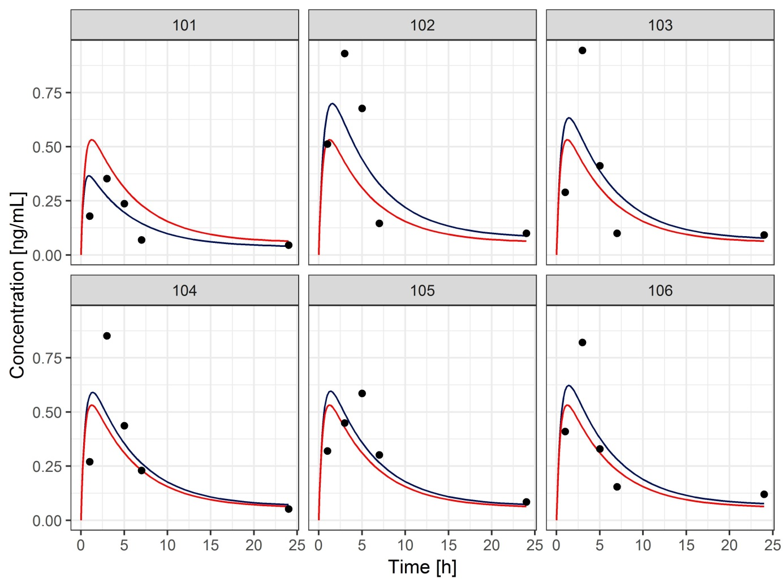
Fig. S1. Individual plasma concentration profiles of tetraene after administration of transdermal patch in 6 subjects with predictions of the pharmacokinetic model (circles – experimental measurements, red line – population prediction, blue line – individual prediction).

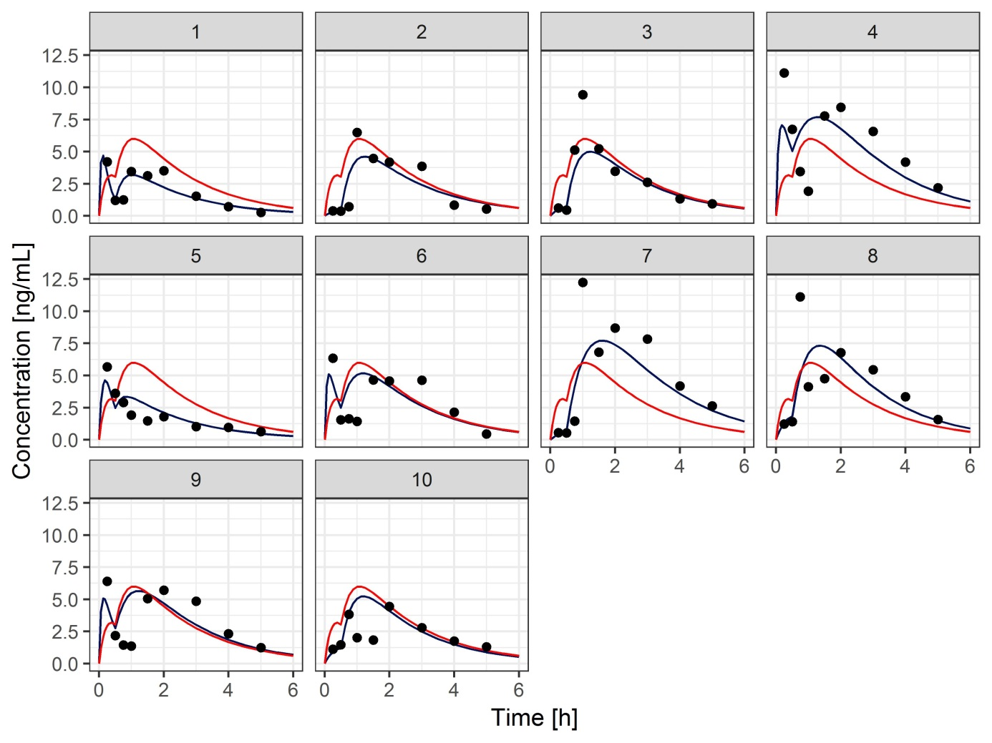
Fig. S2. Individual plasma concentration profiles of tetraene after administration of softgel capsules in 10 subjects with predictions of the pharmacokinetic model (circles – experimental measurements, red line – population prediction, blue line – individual prediction).

